How can I tell if I am a USA Swimming Member
Log onto USASwimming.com
On your Dashboard you should see:
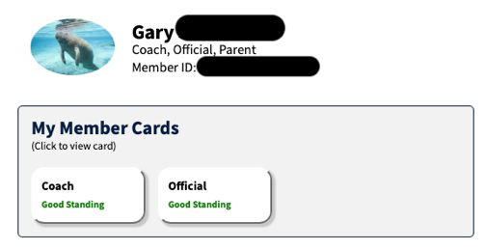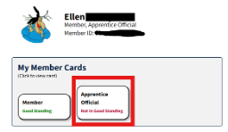
If you click on Official or Apprentice, you will see your Membership card
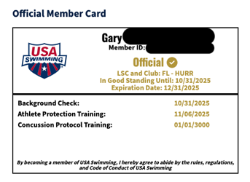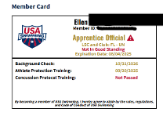
Open the USA Swimming App then click on Member Card on the bottom
Example of the Member Card, in the app
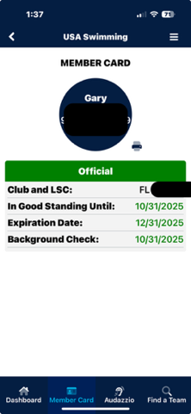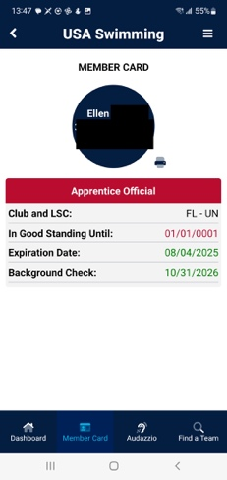

How can I tell if I am a Certified Official
Log onto USASwimming.com
On your Dashboard near the top left you will see Officials:
click Officials then My Official History: it should look like this
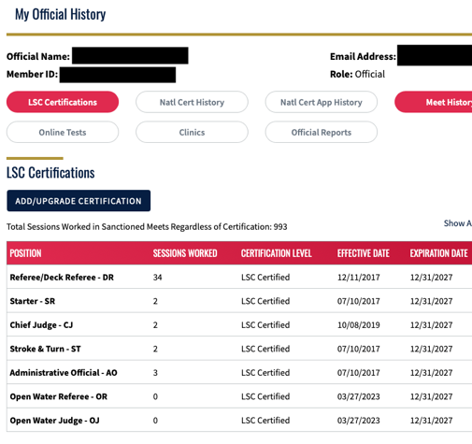

If I want to start Apprenticing and I have not gotten my membership, is a fast way to get this membership. You can click on this link and register for an apprentice membership as Unattached. <CLICK HERE> You can not start Apprenticing until you have a USA Swimming Membership.

